PRODUCT SPECIFICATION
T20LED110S 110V 20W LED TASK LIGHT

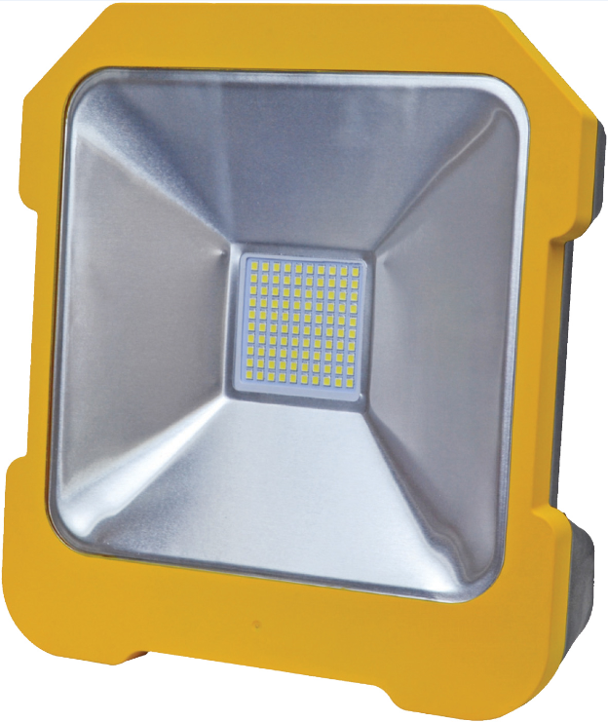

Product name: 20W LED TASK LIGHT
Item No : T20LED110S
Power : 20Watt
LED : SMD2835* 100PCS
Input Voltage: AC 110V

【Datasheet 】

Type | Product | 20W LED TASK LIGHT
Type | Model No | T20LED110S
Type | Product Type | outdoor Lighting
Type | Safety Level | Class II
Type | IP Level | IP54
Type | Safety Certificates | CE
Type | RoHS Directive | Compliant
Electrical | Input Voltage | 110V AC
Electrical | Frequency | 50/60Hz
Electrical | Power | 20Watt
Optical | Cover Material | PC
Optical | Reflector | Mirror reflector
Optical | LED Quantity | 100PCS
Optical | LED | SMD 2835
Optical | Luminous Efficiency(Lm/W) | ≥85Lm/W
Optical | Lumens | 2000lm
Optical | Color temperature(CCT) | 6400K
Optical | Color Render Index(CRI) | Ra≥80
Lamp Structure | Housing Material | Tough Nylon
Others | Application | Outdoor or indoor
Others | Ambient Temperature | -20℃- 55℃
Others | Storage Tempertature | -30℃- 75℃
Others | Life Time | 50000Hrs
Others | Color of lamp | Yellow – Front  Black – Back
Dimension | Power line | 3G 0.75mm² cable
Dimension | Length | 3M cable
Dimension | PLUG | 110V 16A Yellow Plug to EN 60309- Part No. P1134
Dimension | OUTLET | 110V 16A Socket to EN 60309 – Part No. FS1134
Dimension | Connect wire | Brown | L
Dimension | Connect wire | Blue | N
Dimension | Connect wire | Yellow/Green | E
Carton Box Dimension | Quantity of each Carton | 4PCS
Carton Box Dimension | Net Weight | 7.2Kg
Carton Box Dimension | Gross Weight | 7.7kg
Carton Box Dimension | Outer Box Dimension | 55.5X27X32 cm

